11 - Exceptions

Dept of Artificial Intelligence and Machine Learning | Rajalakshmi Engineering College

. 138

Ex. No.

:
11.1
Date: 1/6/24

Register No.: 231501058

Name: M Harish

Out of Range Numbers

Problem Description:

Write a Python script that asks the user to enter a number within a specified range (e.g., 1 to 100). Handle exceptions for invalid inputs and out-of-range numbers.

Input Format:

User inputs a number.

Output Format:

Confirm the input or print an error message if it's invalid or out of range.

For example:

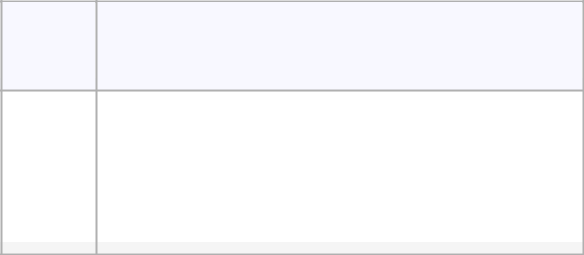

Input Result

 | 1 |  | Valid input.
 | 101 |  | Error: Number out of allowed range
 | rec |  | Error: invalid literal for int()

PROGRAM

try:

num = int(input())

if 1 <= num <= 100:

print("Valid input.")

else:

print("Error: Number out of allowed range")

except ValueError:

print("Error: invalid literal for int()")

Dept of Artificial Intelligence and Machine Learning | Rajalakshmi Engineering College | . 139

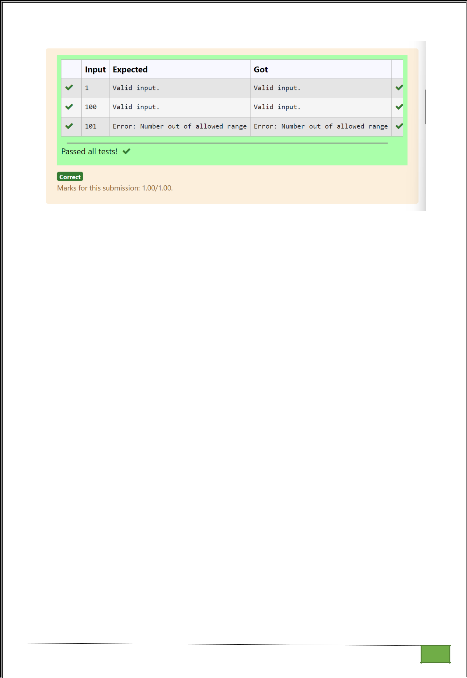

Dept of Artificial Intelligence and Machine Learning | Rajalakshmi Engineering College

. 140

Ex. No. : 11.2 Date: 1/6/24

Register No.: 231501058 Name: M Harish

Divide by Zero

Develop a Python program that safely performs division between two numbers provided by the user. Handle exceptions like division by zero and non-numeric inputs.

Input Format: Two lines of input, each containing a number.

Output Format: Print the result of the division or an error message if an exception occurs.

For example:

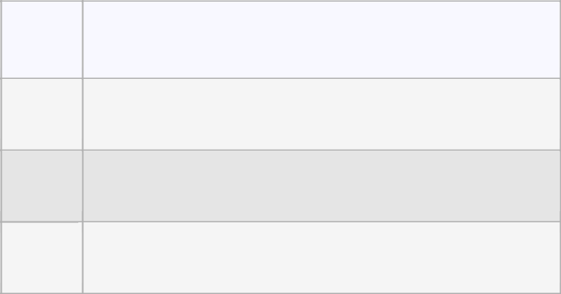

Input Result

- 5.0

- Error: Cannot divide or modulo by zero.

ten | Error: Non-numeric input provided.
5

PROGRAM

try:

a=int(input())

b=int(input())

print(a/b)

except ValueError:

print("Error: Non-numeric input provided.")

except ZeroDivisionError:

print("Error: Cannot divide or modulo by zero.")

Dept of Artificial Intelligence and Machine Learning | Rajalakshmi Engineering College

. 141

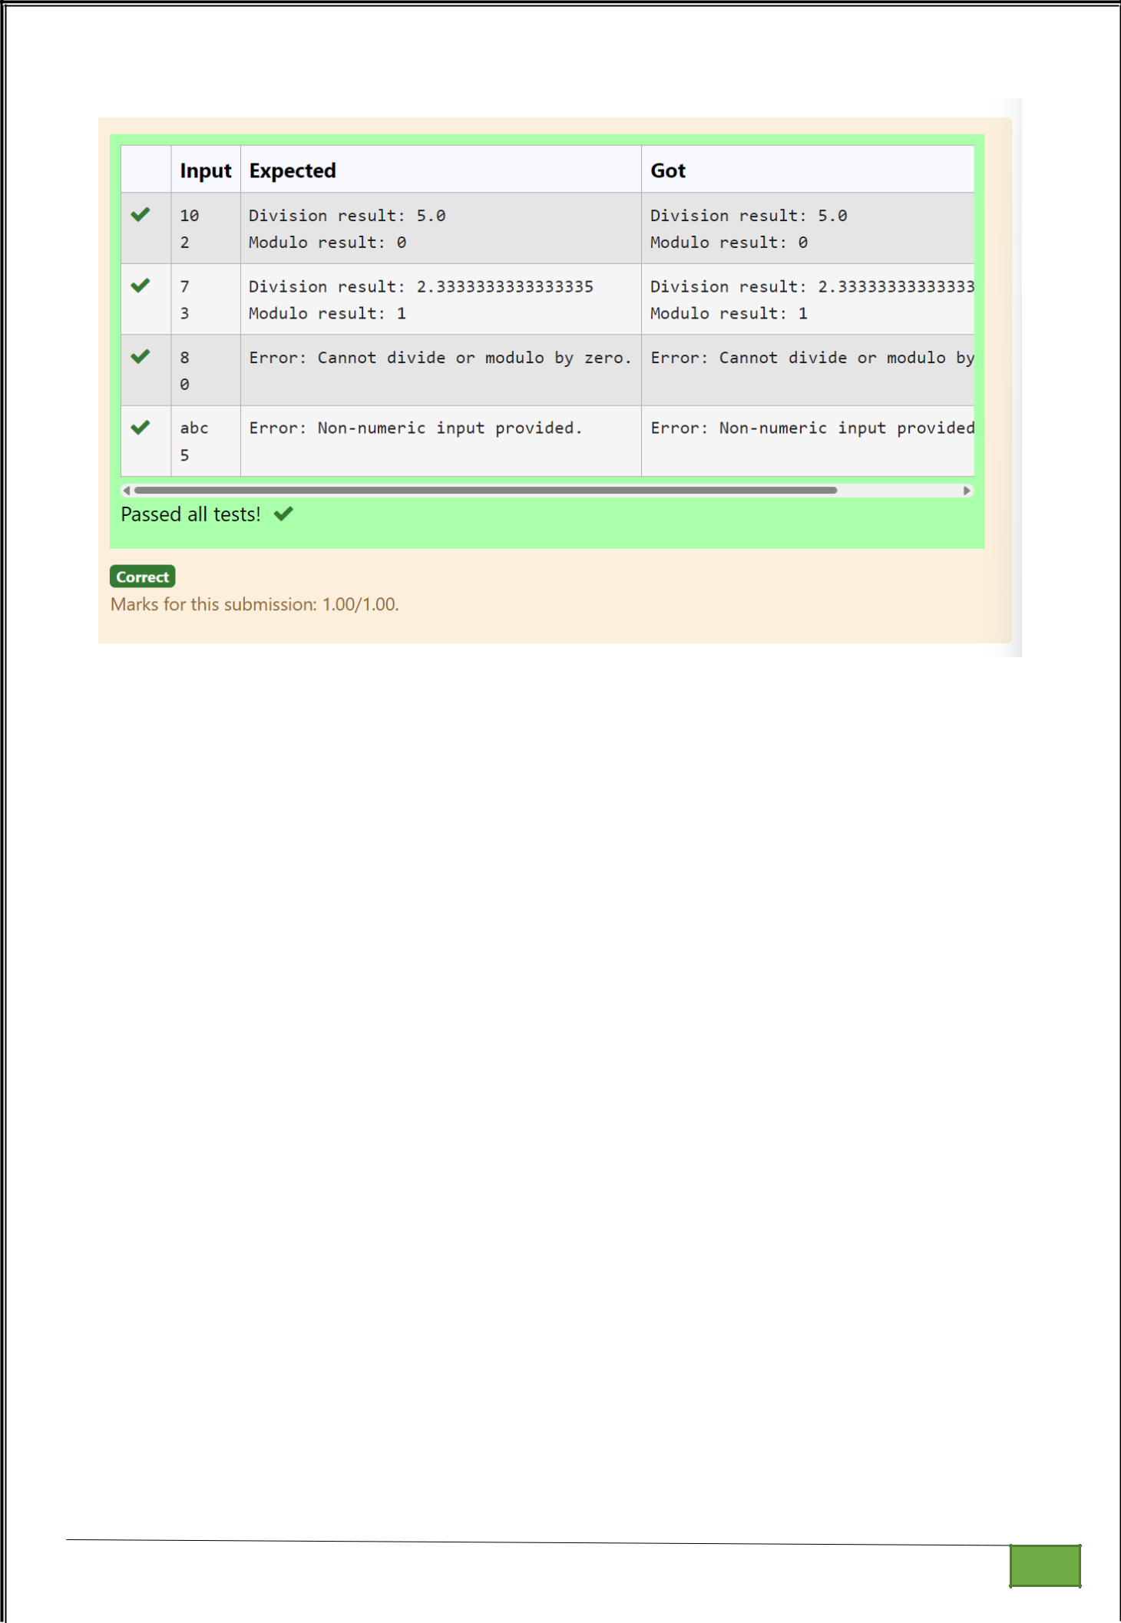

Dept of Artificial Intelligence and Machine Learning | Rajalakshmi Engineering College

. 142

Ex. No.

:
11.3
Date: 1/6/24

Register No.: 231501058

Name: M Harish

Valid Age

Problem Description:

Write a Python script that asks the user to enter a number within a specified range (e.g., 1 to 100). Handle exceptions for invalid inputs and out-of-range numbers.

Input Format:

User inputs a number.

Output Format:

Confirm the input or print an error message if it's invalid or out of range.

For example:
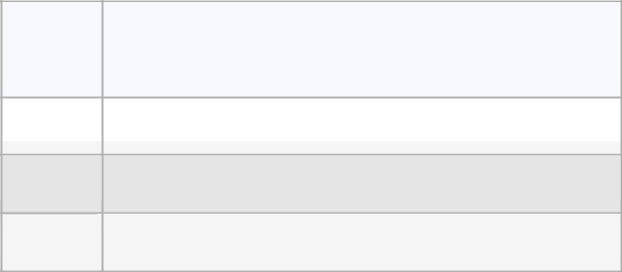

Input Result

1 |  | Valid input.

101 | Error: | Number out of allowed range
rec | Error: | invalid literal for int()

PROGRAM

try:

num = int(input())

if 1 <= num <= 100:

print("Valid input.")

else:

print("Error: Number out of allowed range")

except ValueError:

print("Error: invalid literal for int()")

Dept of Artificial Intelligence and Machine Learning | Rajalakshmi Engineering College | . 143

Dept of Artificial Intelligence and Machine Learning | Rajalakshmi Engineering College

. 144

Ex. No. : 11.4 Date: 1/6/24

Register No.: 231501058 Name: M Harish

Safe Square Root

Problem Description:

Develop a Python program that safely calculates the square root of a number provided by the user. Handle exceptions for negative inputs and non-numeric inputs.

Input Format:

User inputs a number.

Output Format:

Print the square root of the number or an error message if an exception occurs.

For example:

Input | Result
16 | The square root of 16.0 | is 4.00
-4 | Error: Cannot calculate | the square root of a negative number.
rec | Error: could not convert string |  | to float

PROGRAM

try:

a=int(input())

if a>=0:

print("The square root of %.1f is %.2f"%(float(a),float(a**0.5)))

else:

print("Error: Cannot calculate the square root of a negative number.")

except:

print("Error could not convert string to float")

Dept of Artificial Intelligence and Machine Learning | Rajalakshmi Engineering College

. 145

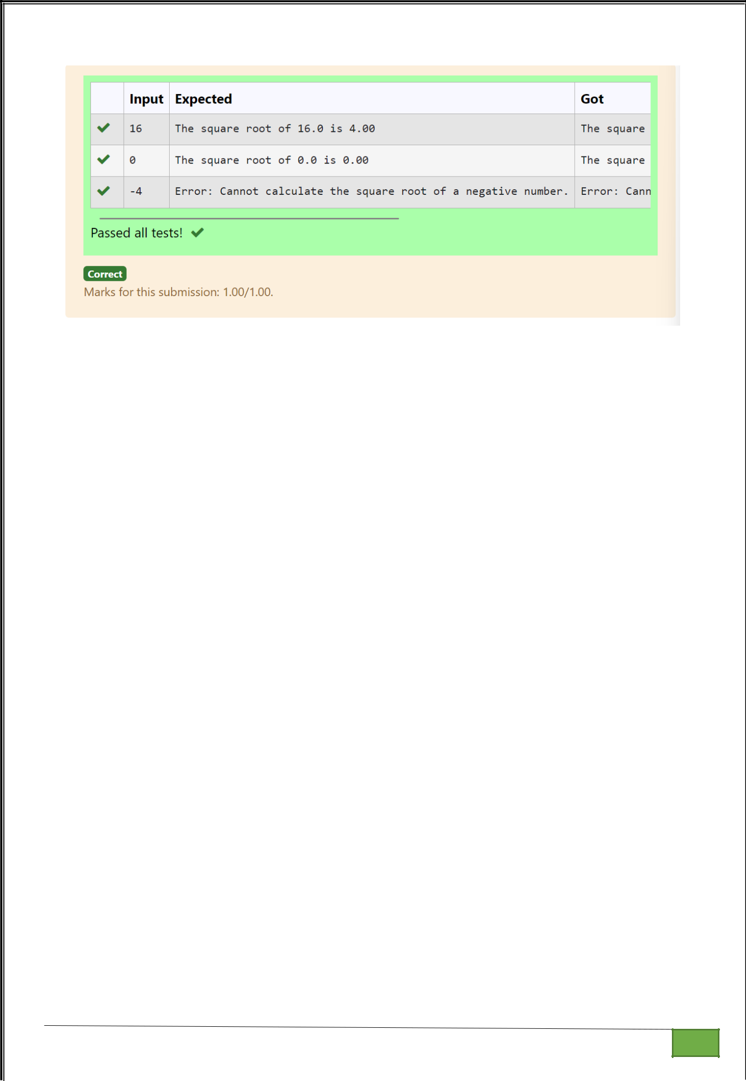

Dept of Artificial Intelligence and Machine Learning | Rajalakshmi Engineering College

. 146

Ex. No.

:
11.5
Date: 1/6/24

Register No.: 231501058

Name: M Harish

Valid Integer

Problem Description:

Write a Python program that asks the user for their age and prints a message based on the age. Ensure that the program handles cases where the input is not a valid integer.

Input Format:

A single line input representing the user's age.

Output Format:

Print a message based on the age or an error if the input is invalid.

For example:

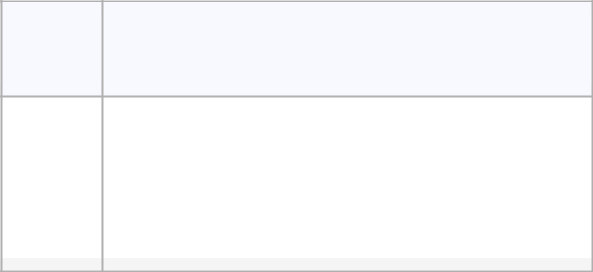

Input Result

 | 25 |  | You are 25 years old.
 | rec |  | Error: Please enter a valid age.
 | -5 |  | Error: Please enter a valid age.

PROGRAM

try:

n=int(input())

if n>=1:

print("You are",n,"years old.")

else:

print("Error: Please enter a valid age.")

except:

print("Error: Please enter a valid age.")

Dept of Artificial Intelligence and Machine Learning | Rajalakshmi Engineering College | . 147

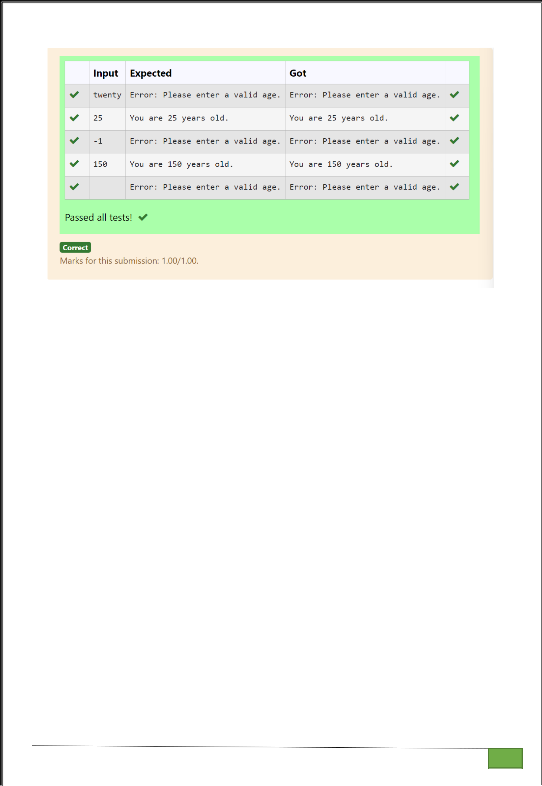

Dept of Artificial Intelligence and Machine Learning | Rajalakshmi Engineering College

. 148

